AWS KMS
Create IAM USER

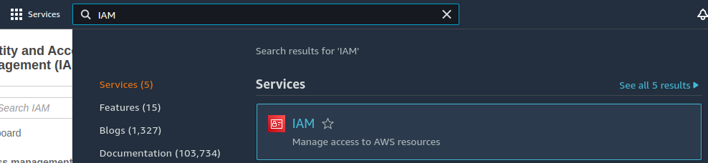
Add Users

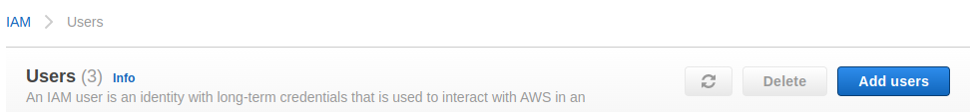
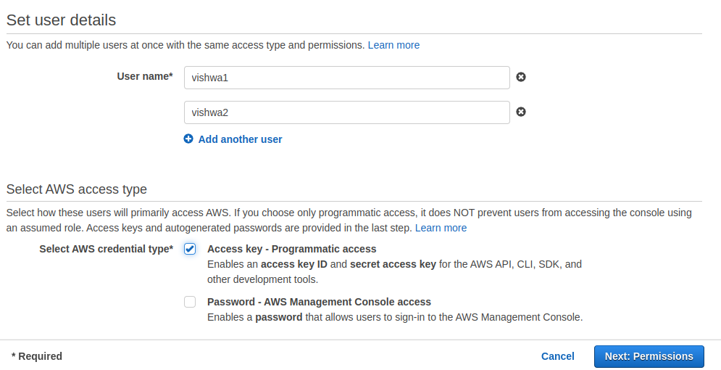
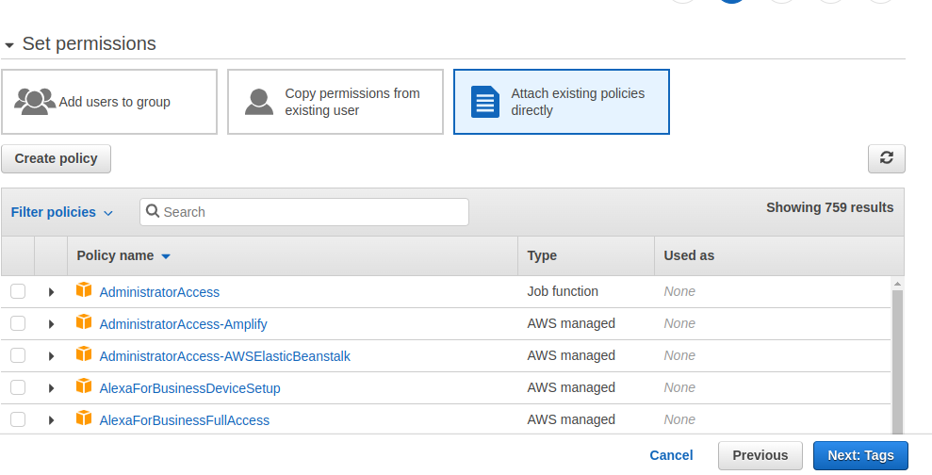

s3 fullaccess
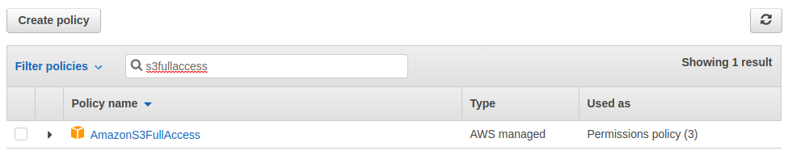
download.csv
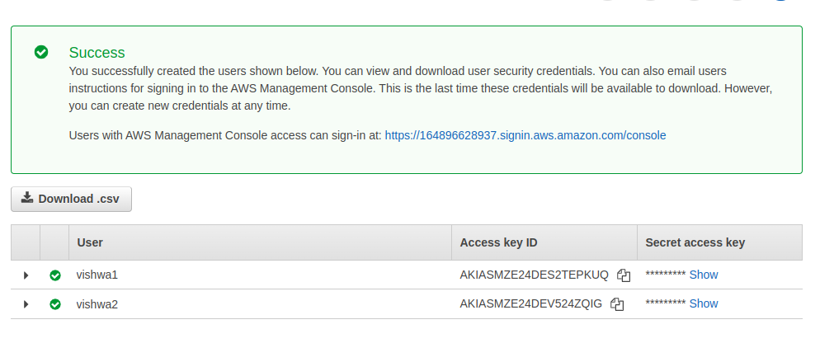
IN security Credential have your access key & secret access key

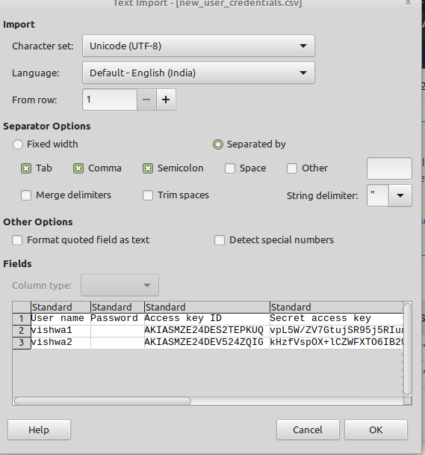

open aws s3 services

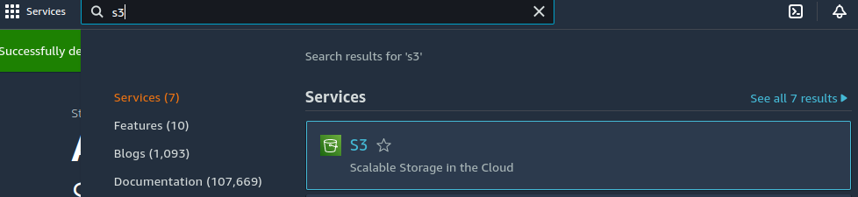
create bucket

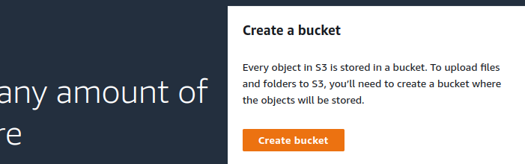
only set bucket name

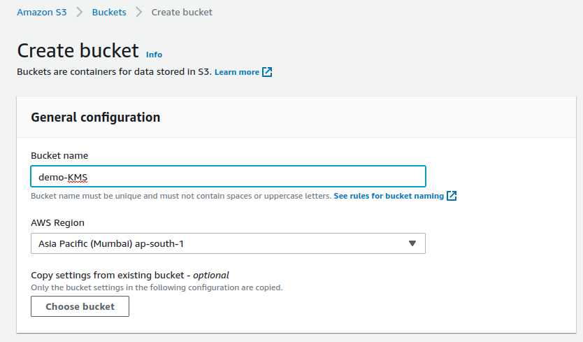

Go to Your base terminal(on-primises)

aws configure

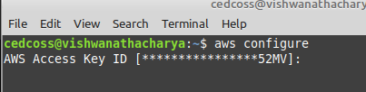

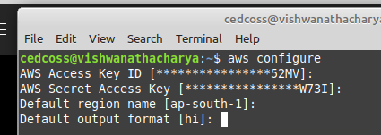

Write aws configure –profile user1

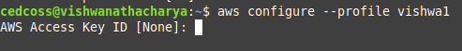
paste here your access key

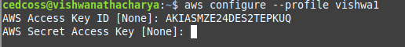
paste your secret access key

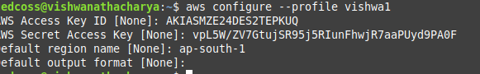
check your profile IAM user Access S3

aws s3 ls –profile vishwa1

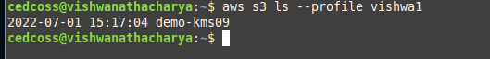

GoTo AWS KMS SERVICES

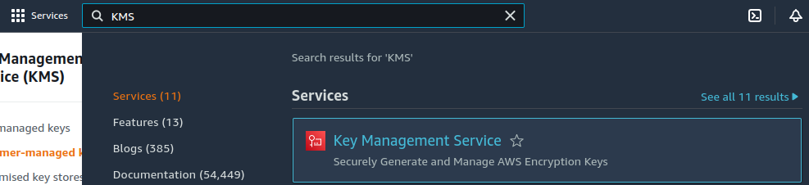
Create Key

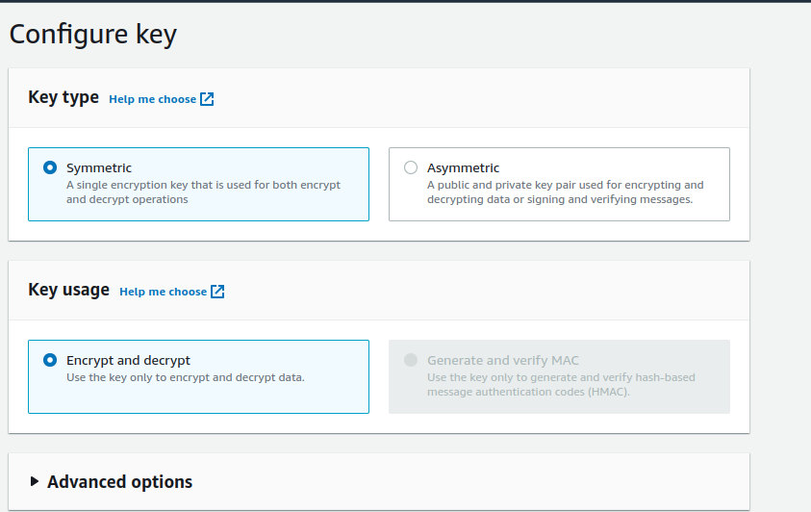
Set Alias Name

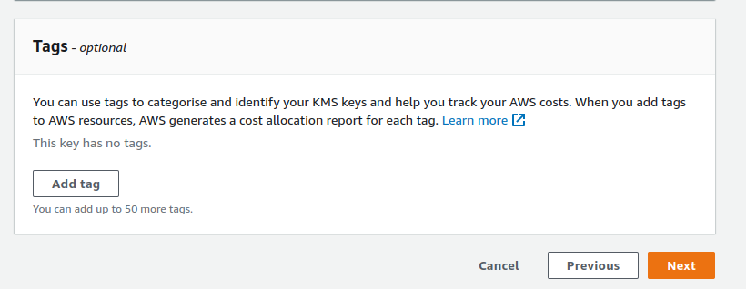
define key administrative permisions

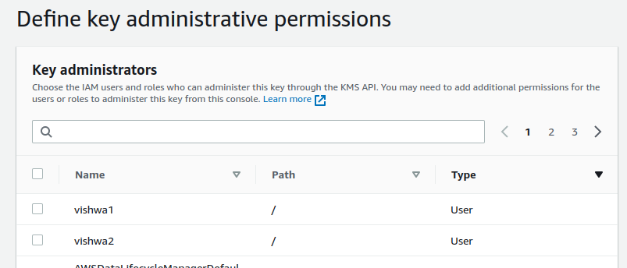
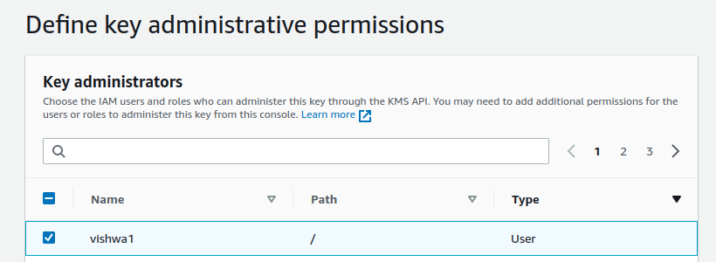
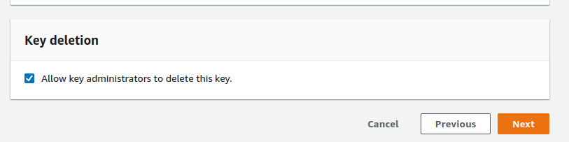
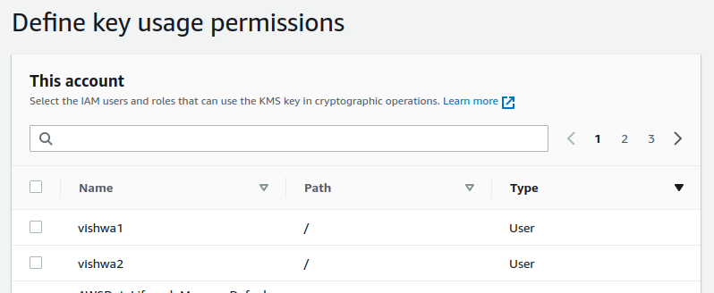
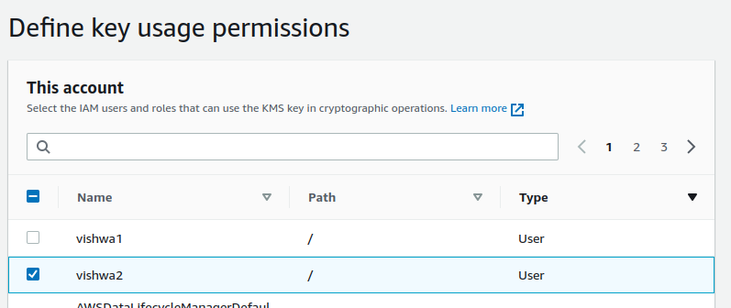
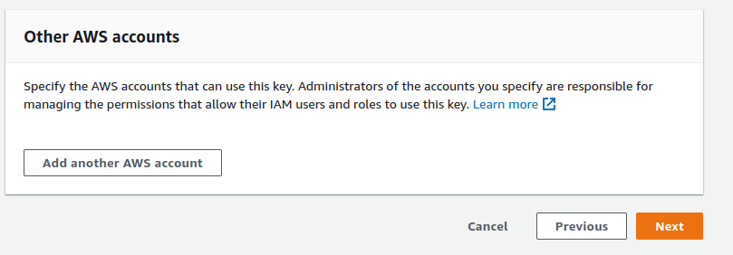
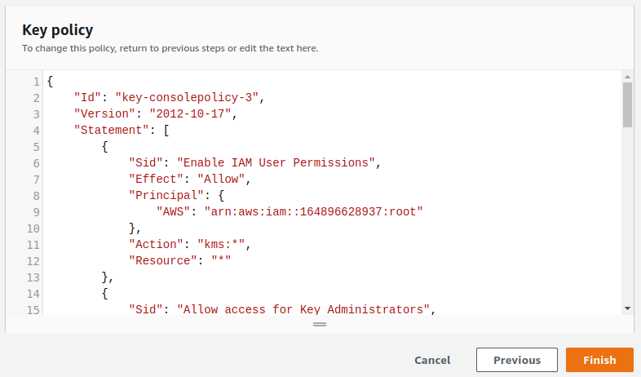
created successfully key

GOTO S3 BUCKET
AND ADD FILE

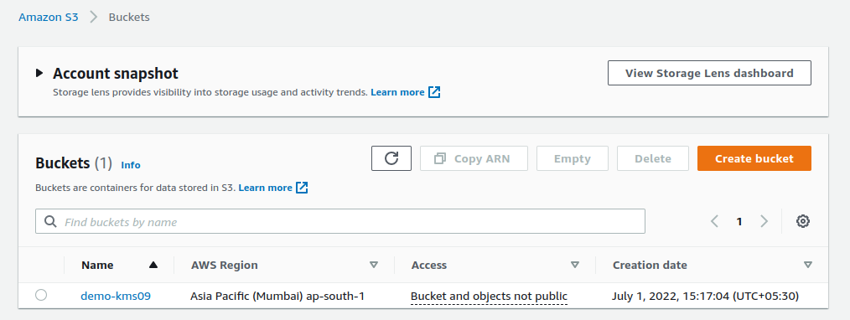
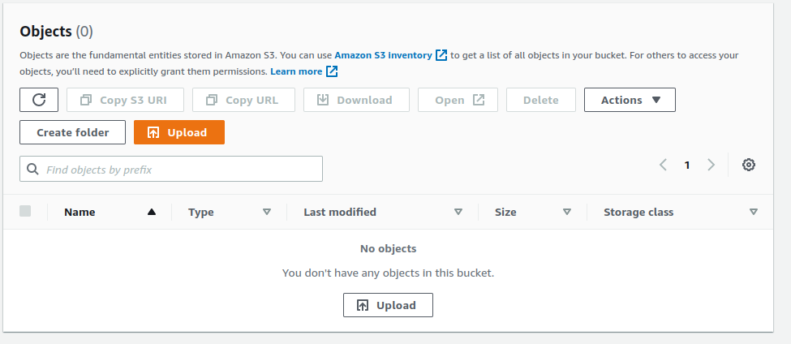
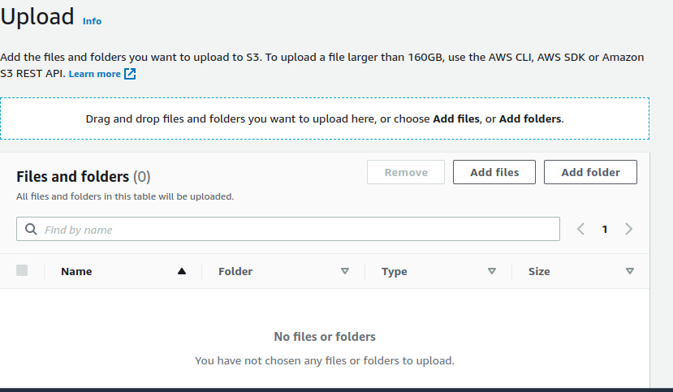
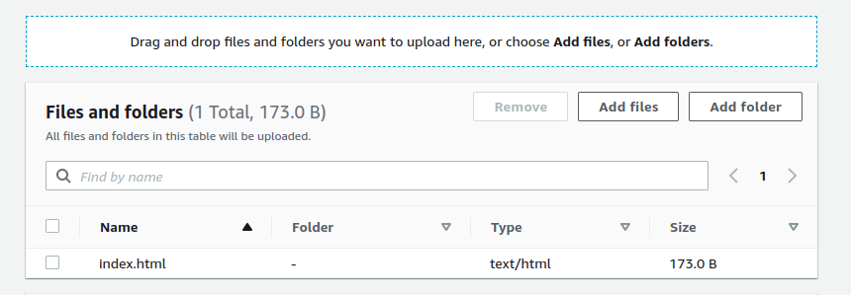

GO TO YOUR BASH TERMIONAL

AWS CONFIGURE

here is your bucket name and under bucket file

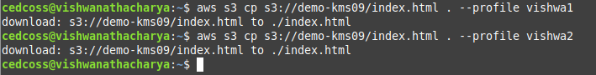
aws s3 cp s3://bucketname/filename . --profile user

Go To S3 Bucket and Properties enable

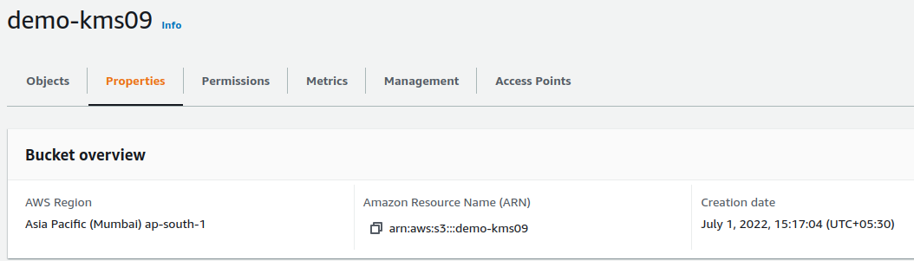
enable default encryption

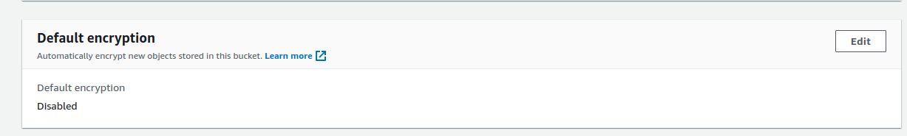
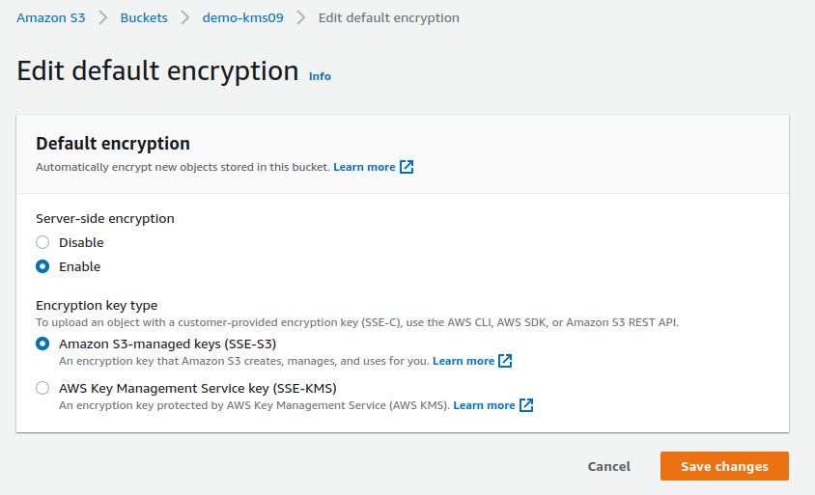

Add KMS on S3 BUCKET OBJECT

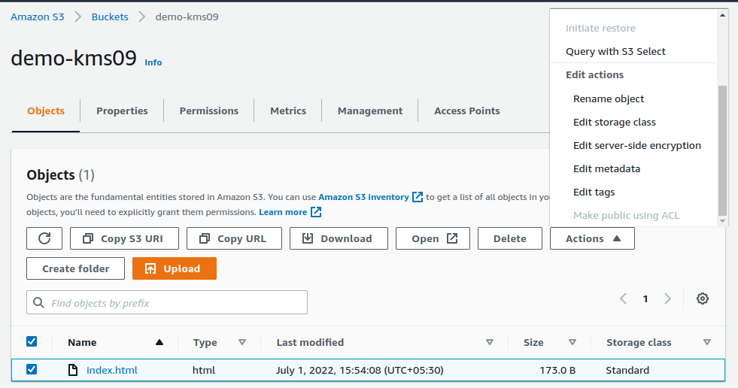
SELECT OBJECT FILE
THAN GO TO ACTION
SELECT EDIT SERVER-SIDE ENCRYPTION

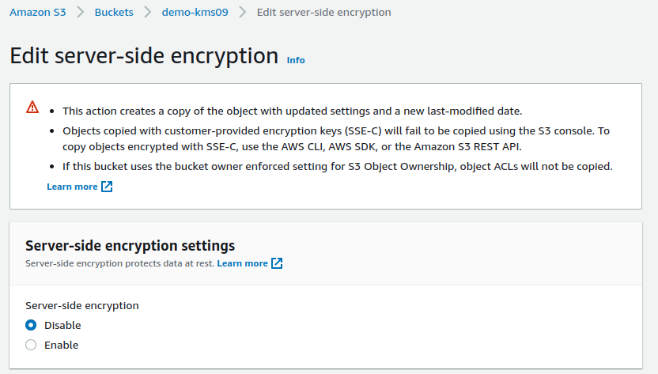

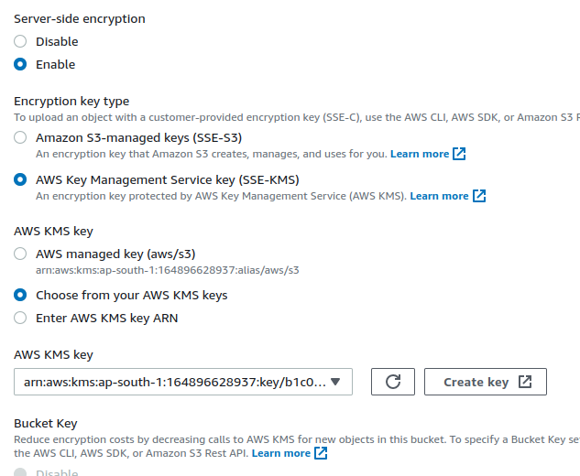
CRATE THAN ITS DONE

